**Instrumentation setup**

***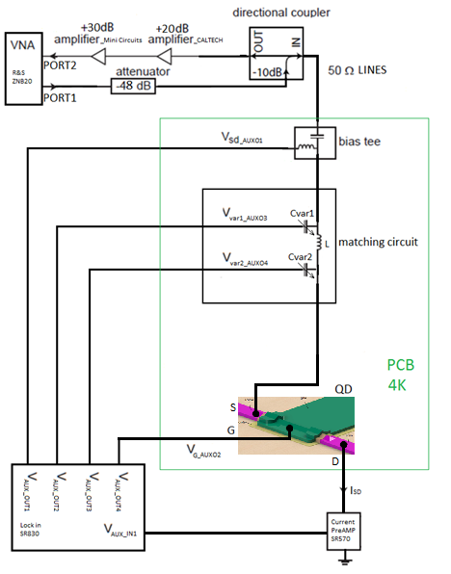***

Figure 6: Simplified schematic of the overall measurement circuit

For conducting the measurements several instruments have been used.

* Reflection coefficient measurement: vector network analyzer (VNA) from Rohde and Schwarz, model ZNB20
* DC biasing of the single hole transistor: auxiliary bias outputs of a Stanford Research SR830 lock-in amplifier
* DC current measurements: current amplifier from Stanford Research SR570
* For attenuating the RF signal sent to the sample: Minicircuit’s attenuator
* For amplifying the reflected from the sample RF signal: series of Minicircuit’s and CITLF3 low noise amplifier
* Instrument control and data retrieval to the PC: Python application.

#### Germanium nanowire based, hole spin single quantum dot tuning and characterization with the initial version reflectometry setup

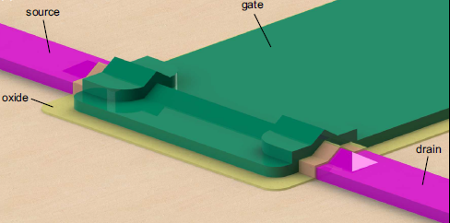

Figure 7: 3D model of a silicon germanium nanowire-based single quantum dot sample SHT, designed by H. Watzinger. A single quantum dot which confines holes is formed in the nanowire beneath the gate (green).

The single hole transistor sample was fabricated by H. Watzinger and the nanofabrication description can be found in [10].

Using the setup described in previous chapter, the SHT formed as a single quantum dot in the germanium nanowire (Figure 7) was tuned in the Coulomb blockade regime applying DC voltages on source, drain and gate electrodes (Figure 6). Charge stability measurements were conducted in the Coulomb blockade regime a showing Coulomb diamond pattern, as in [10]. A Comparison of the DC current and ohmic reflectometry measurements has been done. The DC current was measured by applying a bias on source and reading the current from drain contact (Figure 6), while for the reflectometry measurement the LC matching circuit was connected to the SHT source contact (Figure 6).

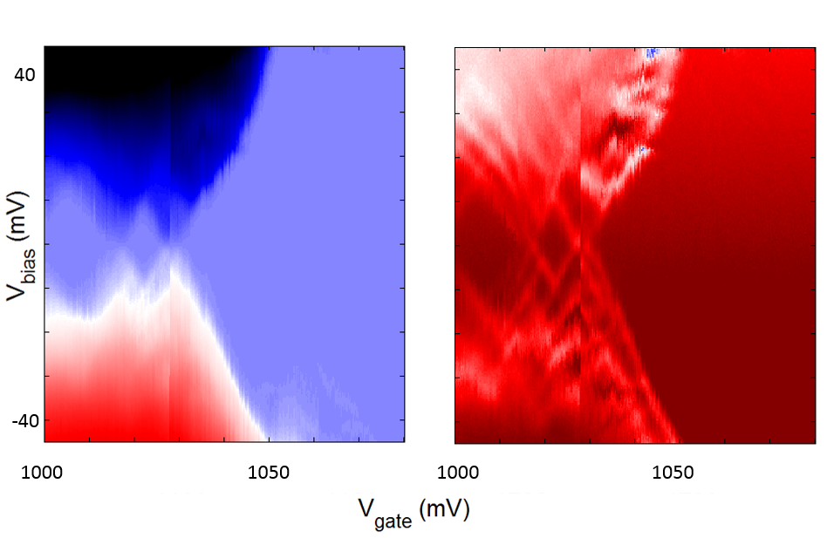

Figure 8: Comparison of the DC current transport (left) and the ohmic reflectometry (right) measurements of the SHT charge stability measurement.

By adjusting the integration time to be similar for both measurements, it can be seen that the reflectometry technique enables us to see more features like the excited orbital energy states of the SHT (Figure 8).

We have compared our reflectometry setup with the result of D. J. Reilly, C. M. Marcus et al where they reported conductance sensitivity of 5\*10-6 e2/h Hz−1/2 by performing reflectometry on the quantum point contact in dilution fridge with electron temperature of 120 mK [19].

In our measurement on the 4K temperature in liquid helium, thermal broadening of the energy levels in the SHT was high causing the SHT resistance change with the small modulation gate voltage applied in the region with the highest slope to be small. Thus, reflected signal amplitude was smaller, which meant lower sensitivity of our reflectometry setup. Conclusively, following the same approach as in [19] we have measured around five times lower sensitivity.

#### Second generation of the reflectometry setup

The first generation of the used setup (at 4K temperature in liquid helium) and PCB board aimed to verify that indeed we have the knowhow to perform RF reflectometry measurements. The second generation of the reflectometry setup will be installed in dilution fridges allowing us to achieve temperatures down to 10 mK. Going lower in temperature, decreases the electron temperature (reduces broadening of the energy levels) needed to resolve the physical effects in the next experiments, and increases reflectometry sensitivity as explained in the previous chapter.

For the purpose of measuring several samples and due to the necessity for a higher number of RF lines dictated by experiments of spin manipulation, a new PCB will be designed. The new design will allow frequency multiplexing of four different reflectometry resonant circuits enabling the measurement of four samples by using just one RF line and amplification stage. We will install in the dilution fridge insert a similar reflectometry system like the one used in the 4K dip-stick. However there will be several improvements. There will be an upgrade in terms of using lower thermal conducting stainless steel and superconducting niobium titanium coaxial cables, attenuators, and additional DC filtering of all the DC wires. In addition, a Niobium titanium superconducting cable is going to be used between the input of the cryogenic amplifier and sample stage because of its very low thermal conduction, to avoid heating of the mixing chamber stage of the fridge which has cooling power of a few tens of μW in the insert.

The vector network analyzer which was used so far for the measurements will be replaced with a Zurich Instruments UHF lock in amplifier which enables faster and longer data acquisition, more inputs and generally more measurement flexibility. For the spin relaxation time and spin manipulation measurement arbitrary waveform microsecond pulses with a nanosecond rise time are needed. Those are generated using a Tektronix AWG5014C. Measurement is conducted using the QTLab measurement application developed in Python initially by Delft Quantum Transport (QT) laboratory. We modified it according to our need. All the codes can be found on the GitHub.

#### Moving to the gate reflectometry

As in the ohmic reflectometry also for the gate reflectometry the readout parameters are the phase shift ∆φ and the amplitude change ∆γ of the reflected signal due to the charge configuration change in the quantum dot or double quantum dot system. , , , where Q is the quality factor of the resonant circuit, Cp is parasitic capacitance, Cg is gate to dot coupling capacitance and CΣ is quantum dot overall capacitance [12]. From the above expressions it can be seen that higher dot to gate coupling Cg leads to higher sensitivity of both ∆φ and ∆γ. The gate electrode and the nanowire separated by a thin dielectric form approximately a parallel plate capacitor structure Using gate reflectometry in gate defined DQD in GaAs J.I. Colless et al, achieved charge sensitivity of 6.3 meHz-1/2, having Cg/CΣ ≈ 0.05 [14]. Using 1.9 nm HfSiON oxide as dielectric in a silicon nanowire field effect transistor, M.F. Gonzalez – Zalba et al. achieved the charge sensitivity of 37 μeHz-1/2, with Cg/CΣ = 0.92 [12]. For comparison, sensitivity achieved using ohmic reflectometry and the rf-QPC as a charge sensor is 100 μeHz-1/2 and using the rf-SET as a charge sensor is 0.9 μeHz-1/2 [12]. In our system using HfO2 as a dielectric, which has εroxide = 24, we can have a film of 4nm in thickness, so we expect to have a Cg/CΣ comparable to that reported in [12].

From the equation for ∆φ, it seems that the strategy for getting a sensitive gate reflectometry setup involves two things. Firstly to reduce the parasitic capacitance as much as possible by engineering the sample holder. Secondly, to tune the reflectometry to the good matching condition by changing the inductor values in the resonant circuit. Explanation why the good matching condition is wanted can be found at the end of the “State of the art” chapter. Q factor dependence about L and C values will be examined.

**The first generation of the gate reflectometry setup will emerge from the second generation of the ohmic reflectometry** by **changing inductor values** and by trying inductors of different core material and size in order to reduce inductor losses.

#### Optimizing the gate reflectometry:

There are several sources for signal loss in a gate reflectometry system: inductor losses, PCB dielectric losses, losses in PCB RF transmission lines, losses caused by the geometric parasitic capacitance [12].

The inductor losses come from the dissipation on the ohmic resistance of the wire wound and core losses due to hysteresis of the core magnetization curve and dissipation caused by eddy currents. The overall loss can be represented by adding next to the inductor a series resistance – equivalent series resistance. Inductors with air core have smaller core losses but for achieving high inductor values they need to have more wounds and they are bigger, lowering their self – resonant frequency and increasing wire resistance. As a part of this work, **examination of the inductor influence** on the gate reflectometry sensitivity regarding the core material and the inductance value will be conducted.

For **minimization of the geometric parasitic capacitance** coming from the coupling of the PCB RF lines and bonding pads to the ground planes, Sonnet software can be used. Simulation of PCB RF lines and bonding pads geometric capacitance in respect to their dimensions, routing configuration and PCB dielectric will be simulated.

Losses in the PCB dielectric will be addressed by using dielectric with lower dielectric loss then currently used FR4, e.g. some of the Rogers Corporation laminates.

The RF lines transmission losses come probably from the unwanted reflections due to the transmission line routing and splitting needed to connect more reflectometry readout circuits – frequency multiplexing. This assumption should be tested and the **optimum configuration of the PCB RF lines** could be achieved by using the Sonnet software for simulating the RF line scattering parameters.

#### Double quantum dot (DQD):

For achieving good state preparation, fast manipulation and fast measurement, additional mechanisms are required beyond ones offered by single QDs. One of the most promising building block for the realization of the spin qubit quantum computer based on quantum dots is serial double quantum dot (DQD) system. A DQD system consists of two neighboring quantum dots tunnel coupled to each other, which simply means that they can exchange charge particles by tunneling. The

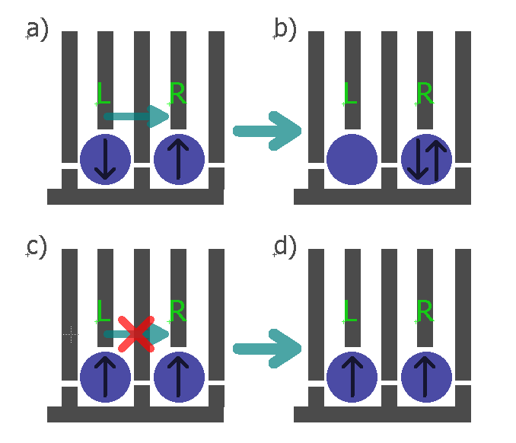

Figure 1: Spin state readout based on spin blockade in gate defined hole double quantum dot. The blue circles represents the individual quantum dots, the grey lines the gates and the black arrows in the QDs the electron spin direction in the left and the right dot.

main physical property which makes them favorable for the realization of a qubit is the Pauli exclusion principle. It says that two identical fermions (in this specific case electrons or holes) cannot occupy same energy state.

Figure 1 describes how spin blockade can be used to extract information about the electron spin in the left QD in the DQD system. If the spin configuration form singlet S(1,1), numbers in brackets denotes hole number on the left and right dot respectively, Figure 1a), then after electrostatic pushing, by applying voltage pulses on gates L and R, hole is allowed to tunnel to the right dot (forming singlet S(0,2)) which, for example, can be detected as the DC current signal. In the other case, Figure 1c), holes in the S(1,1) have same spin and due to Pauli exclusion principle they stay in S(1,1) configuration after electrostatic pushing because next allowed energy state for both holes to be on the right dot, triplet T(0,2) is energetically not available. Consequently, DC current signal does not flow through DQD.

#### Measuring the spin relaxation time T1

Once the gate reflectometry setup will be properly working, I will focus on performing spin manipulation experiments. During my PhD I will focus on the Loss-Divincenzo spin qubit in a double dot device described above.

For measuring the spin relaxation time, approach similar to approach of Koppens et al. [20] will be used. The DQD will be tuned to a the (0,1)-(1,1)-(0,2) triple point The left dot is initially empty while the right dot is populated with a spin up hole. First, pulsing the gate of the left dot brings its spin up and spin down energy levels above the Fermi level, μF, of the lead, allowing lead to dot tunneling of the hole. Since the tunneling is most likely spin independent, the left dot is loaded with a random hole spin from the lead, during the loading time tL. The double dot is left in that configuration for the waiting time tw. After the tw, the second pulse level brings the higher energy spin up level of the left dot in the resonance with the empty spin up level of the right dot (singlet state). If the spin up electron have been loaded to the left dot during the tL, it will tunnel to the right dot in the read phase, causing the shift in the quantum capacitance (capacitance originating from the DQD charge polarization) which is read by the gate reflectometry. Otherwise it will stay on the left dot, causing a zero gate reflectometry readout. The probability of finding the electron in the excited spin-down state will decay exponentially with the duration of the waiting time tw, with *T*1 being the decay constant.

#### Spin manipulation measurements

Quantum gate operations for a spin qubit system implies spin manipulation. Basically such manipulations are spin rotations in the spin representation sphere, called Bloch sphere.



Figure 10. Bloch sphere

The spin-up and spin-down states form the basis of the hole spin qubit and they are located on the north and south pole of the Bloch sphere. Their energy splitting EZ is determined by the hole g factor g, the Bohr magneton μB and a static external magnetic field B, as . The spin vector precesses around the applied static magnetic field (basis states axes) with a so called Larmor frequency , where h is the Planck constant. For flipping the spin an external oscillatory magnetic field BAC needs to be applied perpendicular to the static one and its frequency needs to match the Larmor frequency. An intuitive understanding why the frequency of the BAC needs to match the Larmor frequency can be obtained by thinking of the example of a child on a swing. The child-swing system oscillates with its natural frequency of oscillation. If the swing is pushed by an external person with an appropriate period of pushing pulses, the amplitude of the oscillation will increase and at some point the swing will flip. In this comparison the natural frequency of a child-swing system corresponds to the Larmor frequency and the frequency of externally applied pushing pulses to the frequency of the applied oscillatory magnetic field.

However, an oscillatory magnetic field is hard to implement, from the fabrication standpoint, since it adds more steps and thus the risk of failure. One way to avoid this problem is to apply static a instead of an oscillatory magnetic field and to apply an oscillatory voltage to the quantum dot gate. The oscillatory electric field can modulate the hole g factor giving thus an equivalent to the first case oscillatory magnetic field. Such a technique of achieving the effective oscillatory magnetic by means of static one and g factor modulation is called g-tensor modulation technique.

For generating such high frequency signals, microwave sources are needed because of high Larmor frequencies (10 – 20 GHz, *not sure if you meant that I need to exactly calculate some Larmor frequencies*). For this purpose a signal generator SMF100A (*maybe to put a vector one here*) from Rohde and Schwarz will be used, controlled also from the python measurement application.

#### Measuring the spin dephasing time T2\*

In order to perform next measurements, coherent manipulation of the spin is needed. In order to verify coherent manipulation of the spin, Rabi oscillation experiment will be conducted. DQD will be first initialized in (1,1) charge configuration. Then the spin in the left dot will be rotated for an angle determined by the spin rotation time τBURST , followed by spin readout by trying to push the DQD to the (0,2) charge configuration. If (0,2) configuration is achieved – spin is rotated. By linearly changing τBURST Rabi oscillation pattern [11] should be observed proving the coherent spin manipulation.

Following the approach of R. Maurand et al., for evaluating inhomogeneous dephasing time T2\*, Ramsey – fringes like experiment will be conducted [11]. First, a ∏/2 pulse around x axes is applied to bring the spin vector from north pole (positive z axis) to the xy plane in Figure 10. It stays there for the time τ being exposed to the dephasing noise. After time τ, a second ∏/2 pulse around x axis projects the spin vector back on the z axis for the readout. If no dephasing has taken place, spin should finish at the south pole of the Bloch sphere (spin up state). Linear increase of the τ between the measurement points results in the exponentially decaying spin up state probability, with T2\* being the dephasing time.

#### Spin coherence time experiments:

##### Hahn echo T2

Coherence can be extended by the so called Hahn echo technique which can partially cancel dephasing originating for example from slow varying nuclear magnetic field or applied field inhomogeneities. Similar to the spin dephasing time measurement, after the first ∏/2 pulse around the x axis the spin vector lays in the xy plane. Because of the dephasing sources the spin will dephase in the xy plane for time τ. Then a ∏ pulse around the y axis will be applied which mirrors the spin vector around the y axis. The spin is then left to dephase for the same time, but since it is mirrored, the direction of this dephasing will cancel the previous one, causing the so-called spin refocusing. Followed by another ∏/2pulse around x axis, spin is projected to z axes and a spin up probability is measured. From its exponentially decaying envelope in this case T2ECHO will be extracted.

##### CPMG pulse sequence T2CPMG

In order to extend further the coherence time we aim to use the a sequence of ∏ pulses called the Carr-Purcell-Meiboom-Gill (CPMG) sequence. The ∏ pulses, rotating the spin around the y axis can be applied at the times τ, 3τ, 5τ…, instead of a single ∏ pulse, as in the Hahn echo experiment, for the spin refocusing. Coherence time T2CPMG will be extracted from the exponentially decaying envelope of spin up probability vs ∏ pulses separation time τ. This method is insensitive to the ∏ pulse length errors because the rotation axis alternates between y and –y substracting the pulse length errors [15].

### Innovative aspects:

There has been a huge interest in the past few years in the realization of electron spin qubits in Silicon. In this project a hole spin qubit in a DQD formed in a Ge hut wire will be studied. Despite the interesting electronic properties of this type on nanostructure nothing is known about the spin properties of the confined holes. Due to the low hyperfine interaction and the heavy hole character of the wavefunction very long dephasing times are expected [10],[21]. In addition, easy and fast spin state manipulation is expected because of the in situ present **large spin orbit coupling** for holes in Ge. This should enable **fast spin manipulation** eliminating the necessity for an oscillatory magnetic field. Such a manipulation by means of oscillatory electric fields in combination with the gate reflectometry will dramatically reduce the fabrication complexity since no extra structure (charge sensor, stripline) is required except of already defined gates. Thus this approach has high chances of **addressing the challenge of scalability**.

Finally we aim to achieve the highest reported sensitivity in the gate reflectometry setup. The gates in our DQD system (Figure 2) are positioned very closely to the hut wire (less than 4nm – defined simply by the thickness of the dielectric) in which the QDs are formed. This implies **high capacitive coupling between gate and quantum dots and as a consequence high speed of the gate reflectometry setup** as explained in *Moving to the gate reflectometry* chapter.

### International collaboration:

We are collaborating with the spin qubit team in the group of C. Marcus in Copenhagen, lead by **Ferdinand Kuemmeth**. Actually I have been visiting them for three months end of 2015. Since they are a leading group with a vast knowledge in instrumentation and in the physics of spin dynamics, this collaboration will help me a lot in realizing the proposed project. It would be helpful to visit them once per year to discuss with the technical and physics related questions thus I am requesting 1000 Euro per year as travel expenses.

The other significant collaboration is with Prof. **J.J. Zhang** who is working in the Chinese Academy of Science, in the Institute of Physics in Beijing, China. He is a material scientist providing us with the very high quality Ge hut wires which very few groups around the world can grow.

### Work table:

|  |  |
| --- | --- |
| Task: | Duration: |
| Designing initial version of reflectometry setup | April – September 2015 |
| Germanium nanowire based, hole spin single quantum dot tuning and characterization with the initial version reflectometry setup | September – October 2015 |
| Second generation of the reflectometry setup | January – March 2016 |
| Moving to the gate reflectometry | October – November 2016 |
| Optimizing the gate reflectometry | November – December 2016 |
| Measuring the spin relaxation time T1 | December – January 2016 |
| Spin manipulation measurements | January – February 2016 |

### Contingency plan:

In case it turns out that the gate reflectometry technique is not sensitive/fast enough we are going to use ohmic reflectometry. For that reason a charge sensor proximate to the double quantum dot should be added during the nanofabrication process of the samples. Charge sensing has been recently demonstrated in our group for hut wires [22]. For the charge sensor a single QD located very closely and capacitively coupled to the DQD is going to be used. Whenever the charge configuration will change in the DQD, the impedance of the charge sensor will change and thus the reflected signal amplitude.

### “Something about myself”

**Personal data:**

Name: Josip

Surname: Kukučka

Gender: male

Date of birth: 25.10.1990

Nationality: Croatian

E-mail: [Josip.kukucka@ist.ac.at](mailto:Josip.kukucka@ist.ac.at)

**Working address:**

Am Campus 1,

3400 Klosterneuburg

Austria

*2009 – 2012* Undergraduate studies at the Faculty of electrical and computer engineering, University of Zagreb, Croatia. Bachelor thesis with the professor Tomislav Suligoj, title: “Design and characterization of the F circuits in the HCBT technology”

During my undergraduate study I was praktikum assistant in the course “Electronics” which is mandatory course for all students on the faculty.

*2012 – 2014* Graduate studies at the Faculty of electrical and computer engineering, University of Zagreb, Croatia. Master thesis with the professor Tomislav Suligoj, title: “Design and optimization of the operational amplifier in a BiCMOS technology with the HCBT transistor”

*April 2015 – October 2015* PhD student on the Johannes Kepler University, Institute for Semiconductors and Solid state physics. In the group of Giorgos Katsaros. Developing the ohmic reflectometry system for charge readout of SiGe quantum dots. Printed circuit board design, measurement application development in python, using various DC and high frequency signal instruments, measurement of the single hole transistors based on SiGe nanowire quantum dots, fabricated in our group by Hannes Watzinger.

Conferences: SpinTech VIII – Basel, Switzerland, 10-13 August 2015, SiSpin meeting - IST Austria – 10-11 September 2015

*October 2015 – January 2016* Research visit to the Center for Quantum Devices, Niels Bohr Institute, Copenhagen. I was working in a group of people who are trying to develop spin based qubit in GaAs and Si/SiGe lithographically defined double and triple quantum dots. They are one of the biggest and most successful groups in the field of quantum computation. So, I learned about high end laboratory equipment including cryogen free dilution refrigerators, waveform and signal generators, RF equipment (amplifiers, fliters, coaxial cables… ). I was following the experiment of Filip Malinowski – tuning the GaAs double and triple quantum dot for coherent spin manipulation and readout using charge sensor ohmic reflectometry.

*February 2016 –* Present PhD student on the Institute of Science and Technology (IST), Austria. In the group of Georgios Katsaros. Developing the second version of the reflectometry readout system. Setting up instrumentation for spin relaxation time measurements. Spin relaxation time measurement T1 of the SiGe nanowire based Loss-Divincenzo spin qubit, with Lada Vukušić.

Conference: New Developments in Solid State Physics, Maunterdorf, Austria, 21 - 26 February 2016

**What is still missing is a kind of one page description of the project in the beginning, an abstract**

THINGS THAT ARE KICKED OUT, BUT MAYBE SOME OF THOSE CAN BE IMPLEMENTED ABOVE:

### Overall goal of the project:

To implement one of the Loss and DiVincenzo’s criteria:

* **strong quantum measurements**,

and conducting **experiments of spin manipulation**.

Strong quantum measurements can be achieved by implementing gate reflectometry in our type of qubit structures. After having state readout solved, spin manipulation experiments can be done by applying bursts of microwave signal on electrostatic gates *(as explained in research methods).*

Spin manipulation experiments will be guideline for achieving second of the Loss and DiVincenzo’s criteria:

* accurate quantum gate operations

## Specific aims

### Clear aims:

Samples are done in cleanroom… *(take from someone in group)*

All experiments are done on DQD and TQD samples placed on the printed circuit board (PCB) sample holder *(put the picture)* in the dilution refrigerator with a base temperature of 10 mK.

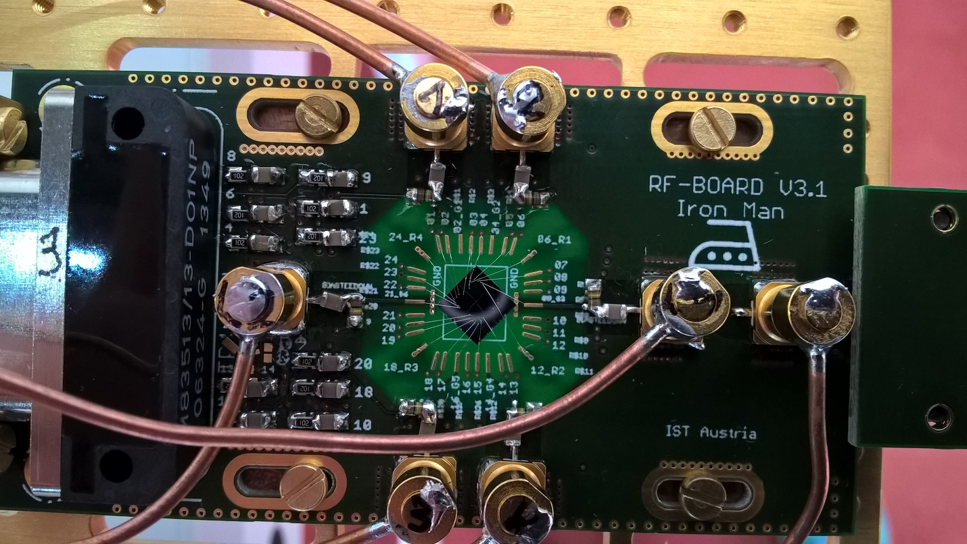

Fig. x1. PCB holder (green) with mounted nanowire based sample (middle, grey) fabricated in our group by Lada Vukušić. Altogether mounted on golden plated copper fork on the dilution fridge insert. Copper wires are coaxial cables providing high frequency connection for spin manipulation and readout. Nanometer gates and ohmic contacts on the sample are connected by wedge wire bonding.

Electrical connection with the sample is achieved through thermally low conductive looms for DC signals and coaxial cables for RF and microwave signals. *(put the picture of the probe)* All cables finish in PCB connector and further electrical contact with the sample is achieved by wedge wire bonding.

On room temperature side there are several instruments for sending and receiving the signals from the sample. Firstly, DQD and TQD needs to be tune in correct electrostatic configuration what is achieved through the low-noise, optically isolated, voltage DC sources.

Sequences of high-speed pulses (ranging from hundreds of nanoseconds to several milliseconds) coordinated together with bursts of microwave signals (several GHz up to several tens of GHz) are sent via coaxial cables to manipulate DQD and TQD charge and spin state thus **providing spin qubit manipulations**.

Pulses are generated by arbitrary waveform generator (Tektronix AWG5014C) and microwave signals by microwave signal source (Rohde & Schwarz SMF100A).

**Qubit state is read-out** by probing radio-frequency (RF) signal reflected from resonant circuit consisted of discrete inductor and capacitor and gate capacitance between DQD and TQD top gates and confined charge area in those. Probing is done by high frequency lock-in measurement technique using Zurich Instruments UHFLI lock-in amplifier.

### Hypoteses:

*(Don’t know what to put here and what in research metodology)*

Main hypotheses is that our gate reflectometry is sensitive enough to achieve fast quantum state readout. Read out parameter (one which needs to be boosted) by gate reflectometry is resonance frequency shift ∆f due to hole tunneling form one to another dot in DQD or TQD system: . Resonant frequency, , of resonance circuit depend on externally added lumped inductance L which is externally added, and parasitic capacitance Cp. Because L is easily tunable and Cp can be reduced to some level by engineering, main hypotheses is that quantum capacitance due to a hole tunneling, CQ is big. It is given by our sample and we expect it to be relatively high because of the following reasons.

*(This need to be changed according to Csigma)*

CQ depends on capacitive coupling of reflectometry readout gate to QDs in a qubit Cg, and parasitic capacitances Cp, according to:

Previous expression suggest that pathway for boosting sensitivity of gate reflectometry is to have Cg high and Cp low.

Since in our types of structures gates are positioned on the top of the nanowire (d is small, l and w are relatively large) consisting QDs (Fig 1.) we expect high Cg ,according to:

Small parasitic capacitance we are going to achieve by engineering our sample holder (PCB). Isolating PCB sample area from the ground by removing ground planes and decoupling RF and DC ground by putting relatively large resistors in DC line around that area. On Fig.x.1. around the sample PCB is translucent indicating that there is no copper ground plane.



Figure 1. Nanowire based single quantum dot, predecessor of double quantum dot on Fig.x.

## Research methods

Here we are proposing integration of two qubit Loss and DiVincenzo’s criteria in our type of qubit. First is **qubit state (spin) readout**. Other one is **spin state manipulation**.

### Qubit state readout:

C:\Users\jkukucka\Desktop\IST\DOC Fellowship\DQD_reflectometry.tif

Figure 2. Gate reflectometry schematic on the DQD sample from Fig.x1. LC resonators are connected to three of the gates. Signal from different gates are distinguished by frequency multiplexing since resonant frequencies are different because of different inductor values.

**What is reflectometry?**

Reflectometry is readout technique based on change of wave reflection coefficient Γ. It comes from electromagnetic wave principle – if the wave is travelling in media with impedance Z0  (e.g. coax cable) and it encounters change of impedance (e.g. coax end) to Z, portion of the wave will be reflected back according to the expression: , where Ar is amplitude and ᵠ( Ar) phase of the reflected, and Ain amplitude and ᵠ(Ain) phase of incoming wave. Reflection coefficient phase is ᵠ(Γ).

Putting resonant circuit with incorporated device instead of coax cable end one can measure change in impedance (capacitance) of that device. If elements of a resonant circuit – inductance L and capacitance C are properly chosen, on the resonant frequency of that circuit, , wave reflection coefficient Γ is minimized and it’s phase has inflection point and highest slope, Fig 2. top right blue and red.

In case of resonant LC circuit consisted of just L and C with very small R, Z is almost purely imaginary consisting of inductive and capacitive reactance. Thus if capacitance of sensed device changes -> ᵠ(Γ) changes and so phase of reflected wave ᵠ( Ar). Thus, by measuring phase of reflected wave ᵠ( Ar) and comparing it with ᵠ(Ain) one can get information of the impedance (capacitance) of sensed device.

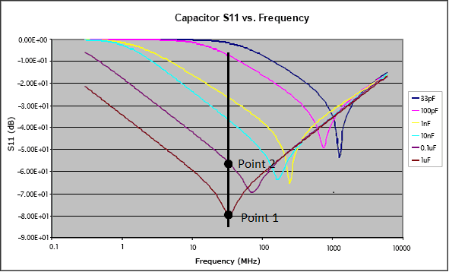

Fig 3. S11 parameter vs frequency for different capacitors *(put something from qucs instead of this one)*

**Our plan:**

RF wave (tens to hundreds of MHz) is generated and sent from UHFLI out port down the coax cable. Going through directional coupler and encountering three resonant circuit frequency multiplexed on different resonance frequencies by choosing different values for surface mount inductors L1, L2, L3. Each of this inductors will be wire bonded to finger like gates, as shown in Fig 2. Here is an example for nanowire, double quantum dot based qubit. Gates LP (left plunger) and RP (right plunger) are capacitively coupled to the left and right quantum dot respectively. When electron undergo tunneling between the dots there is an onset of quantum capacitance, changing overall capacitance seen by the resonant circuit, which changes resonance frequency (according to expression for f0) and consequently amplitude and phase of reflected wave which is then measured.

### Spin state manipulation:

*Write something about it*

# References:

J.I.Colless, Dispersive Readout of a Few-Electron Double Quantum Dot with Fast rf Gate-Sensors”

Some lecture: <http://www.physics.udel.edu/~msafrono/650/Lecture19.pdf>

About inductors: <http://info.ee.surrey.ac.uk/Workshop/advice/coils/air_coils.html>,

http://e-collection.library.ethz.ch/eserv/eth:5129/eth-5129-02.pdf

1. Platzman, P. M.; Dykman, M. I.; *Science* **1999,** *284,* 1967-1969
2. Jarryd J. Pla et al., *Nature* **2013** 496, 334–338
3. Jarryd J. Pla et al., *Nature* **2012** 489, 541–545
4. A. Morello et al., *Nature* **2010** 467, 687
5. Xiaobo Zhu1 el al., *Nature* **2011** 478, 221–224
6. H. Paik et al., *Phys. Rev. Lett.* **2011** 107, 240501
7. David P. DiVincenzo, [*arXiv:quant-ph/0002077v3*](http://arxiv.org/abs/quant-ph/0002077v3)
8. [F. K. Malinowski](https://arxiv.org/find/cond-mat/1/au:+Malinowski_F/0/1/0/all/0/1); [F. Martins](https://arxiv.org/find/cond-mat/1/au:+Martins_F/0/1/0/all/0/1); [P. D. Nissen](https://arxiv.org/find/cond-mat/1/au:+Nissen_P/0/1/0/all/0/1); [E. Barnes](https://arxiv.org/find/cond-mat/1/au:+Barnes_E/0/1/0/all/0/1); [Ł. Cywiński](https://arxiv.org/find/cond-mat/1/au:+Cywinski_L/0/1/0/all/0/1); [M. S. Rudner](https://arxiv.org/find/cond-mat/1/au:+Rudner_M/0/1/0/all/0/1); [S. Fallahi](https://arxiv.org/find/cond-mat/1/au:+Fallahi_S/0/1/0/all/0/1); [G. C. Gardner](https://arxiv.org/find/cond-mat/1/au:+Gardner_G/0/1/0/all/0/1); [M. J. Manfra](https://arxiv.org/find/cond-mat/1/au:+Manfra_M/0/1/0/all/0/1); [C. M. Marcus](https://arxiv.org/find/cond-mat/1/au:+Marcus_C/0/1/0/all/0/1); [F. Kuemmeth](https://arxiv.org/find/cond-mat/1/au:+Kuemmeth_F/0/1/0/all/0/1), [*arXiv:1601.06677*](https://arxiv.org/abs/1601.06677)
9. J. R. Petta et al., [*Science* **2005**309, 2180](http://pettagroup.princeton.edu/publications/2005/Science_309_2180_2005.pdf)
10. H. Watzinger et al., *[arXiv:1607.02977](https://arxiv.org/abs/1607.02977)*
11. R. Maurand et al., [*arXiv:1605.07599*](https://arxiv.org/abs/1605.07599)
12. Gonzalez-Zalba, M. F. et al., *Nat. Comm.*  2015 6, 6084
13. N. Ares et al., *Phys. Rev. Applied* 2016 5,034011
14. J. I. Colless et al., *Phys. Rev. Lett.* 2013 110, 046805
15. Juha T. Muhonen et al., *Nature Nanotechnology* 2014 9, 986–991
16. C. Fasth et al., *Nanoletters* 2005 5, 1487-1490
17. [M. Veldhorst](http://www.nature.com/nature/journal/v526/n7573/abs/nature15263.html#auth-1)., *Nature 2015* 52,410–414
18. [E. Kawakami](http://www.nature.com/nnano/journal/v9/n9/abs/nnano.2014.153.html#auth-1) et al., *Nat. Nanotechnology* 2014 9, 666–670
19. [D. J. Reilly](http://scitation.aip.org/content/contributor/AU0359152;jsessionid=0v5VY-bGXJiQk8fx_SoWO4Dw.x-aip-live-02) et al., *Appl. Phys. Lett.* 2007 91, 162101
20. F. H. L. Koppens et al., *Nature* 2006 442, 766-771
21. Jan Fischer and Daniel Loss, *Phys. Rev. Lett.* 2010 105, 266603
22. L. Vukusic et al., unpublished data

G. Katsaros, Marie Curie proposal